Secretariat Use Only 秘书处专用
S/N 编号：

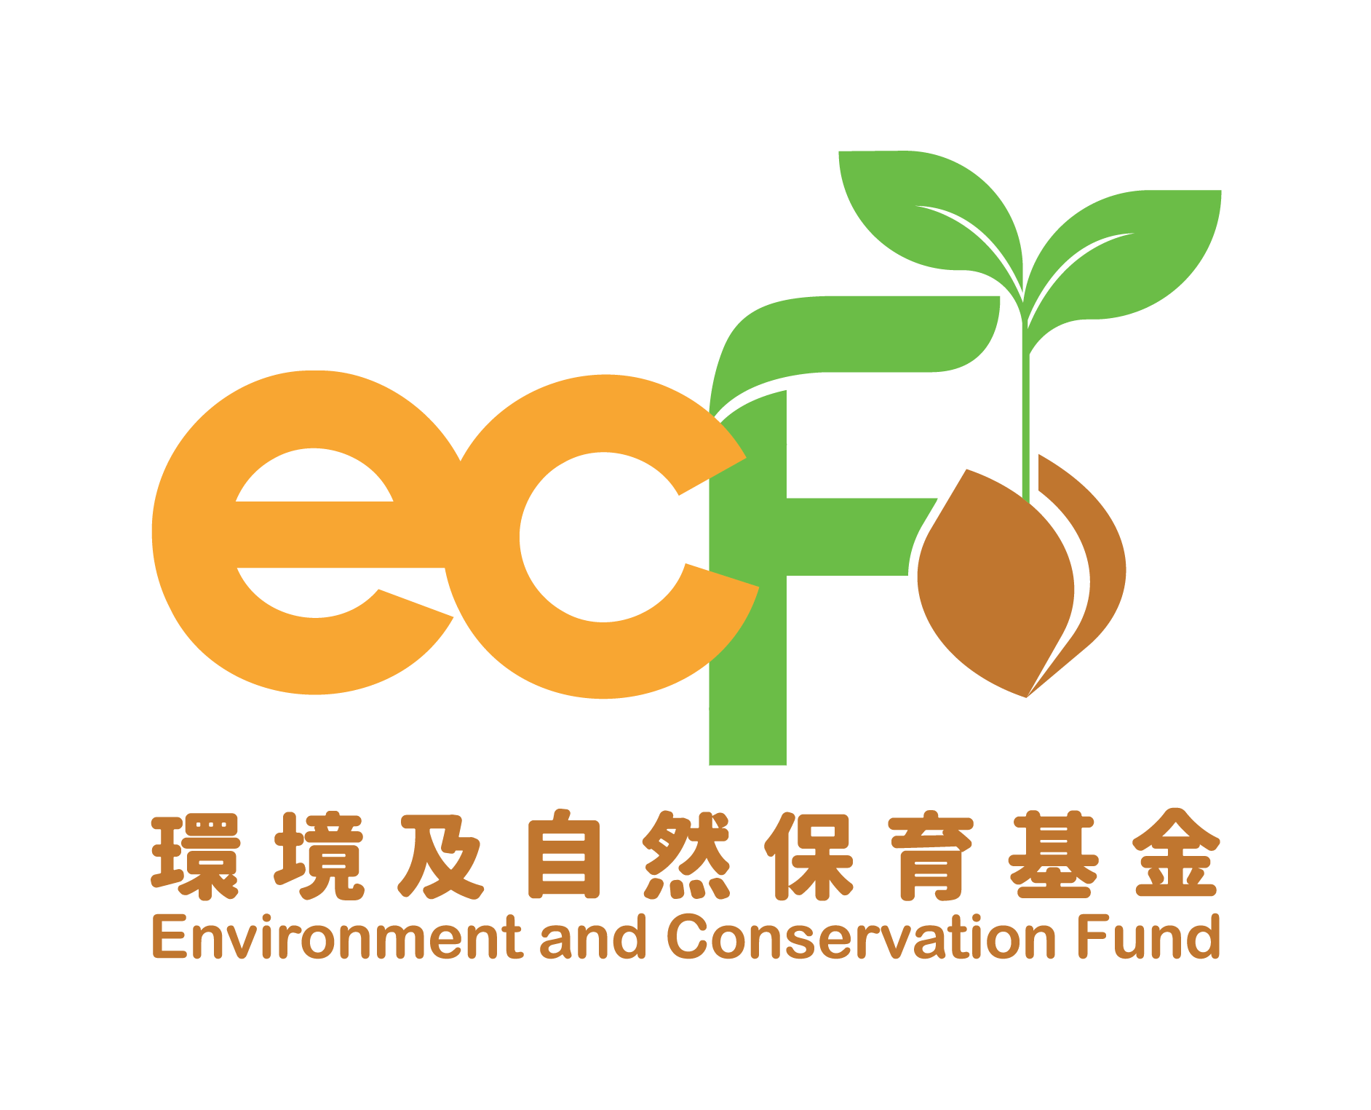 | ENVIRONMENT AND CONSERVATION FUND  环境及自然保育基金  Publicity and Education Projects  宣传及教育项目  Application Form for  Small Scale Project on Clean Shorelines  清洁海岸小型项目申请表格

Application Guideline 申请须知

This Application Form may be amended by the Environment and Conservation Fund (ECF) Committee, Publicity and Education Projects Vetting Subcommittee (the Vetting Subcommittee) and the Vetting Subcommittee Secretariat (the Secretariat) as and when necessary.
环境及自然保育基金委员会、宣传及教育项目审批小组（审批小组）及审批小组秘书处（秘书处）可随时按需要修订本申请表格的内容。

The soft copy of the Application Form can be downloaded from the website of the ECF at:
申请表格的软复本可从环境及自然保育基金网页下载，网址如下：

- https://www.ecf.gov.hk

Please read the “Guide to Application – Publicity and Education Projects” carefully and provide all details of the proposed project in a clear and concise manner. The Application Form may be completed in Chinese or English. Additional pages may be attached to the form if necessary.
请详阅《宣传及教育项目－申请指引》，并清晰及简洁地提供建议项目的详情。请以中文或英文填写本申请表格。如有需要，可另页书写。

All sections of the Application Form should be completed with all required information and supporting document(s) wherever required. Please ensure that all required information is submitted together with the Application Form. Where the information sought is not applicable or not available, please fill in “NA”.
申请表格的所有部分均须填写；请确保所有需要的数据及证明文件均连同申请表格一并递交。如所须填报的资料为不适用或未能提供有关资料，请填上「不适用」。

Applicant organisation is required to complete Appendix I of the application form – Agreement. An application will be considered invalid if the Appendix is not duly signed and submitted along with the application.
申请机构须填妥申请表格附录I - 确认书。如无妥为签署并连同申请表格一并递交此附录，申请将被视为无效。

For paper-based applications, the Application Form should be printed on both sides of the paper. Both original hard copy and soft copy (“Word” format) of the Application Form shall be submitted.
就纸本申请而言，申请表格应双面打印。申请表格的正本及软复本（「Word」文件格式）须一并递交。

The duly completed Application Form (together with all supplementary/supporting documents) must reach the Secretariat by the application deadline, i.e. before 6:00 pm on 27 December 2024 by the following means:
填妥的申请表格（连同所有补充或证明文件）须于截止申请日期（即2024年12月27日）下午6时前，透过以下方式送达秘书处：

- In person or by post:
亲身或以邮寄：

Publicity and Education Projects
Vetting Subcommittee Secretariat
Environment and Conservation Fund
5/F Southorn Centre, 130 Hennessy Road, Wan Chai, Hong Kong

香港湾仔轩尼诗道130号修顿中心5楼
环境及自然保育基金
宣传及教育项目审批小组秘书处

- By email (Email address: ecf@eeb.gov.hk)
电邮（电邮地址：ecf@eeb.gov.hk）

Please mark “P&E Projects — Small Scale Project on Clean Shorelines” on the envelope or as the email title.
信封面或电邮标题请注明「宣传及教育项目 — 清洁海岸小型项目」。

For applications submitted by post, the postmark should be dated on or before the application closing date. Otherwise, it will be regarded as late applications. Please ensure payment of sufficient postage as underpaid mails will not be accepted. Applicant organisations will bear any consequences arising from paying insufficient postage. In case Tropical Cyclone Warning Signal No. 8 or above is hoisted, or Black Rainstorm Warning Signal / Extreme Weather Condition announced by the Government is/are in force for any duration between 12:00 noon and 6:00 pm on the application closing date, the application closing time will be extended to 6:00 pm on the next working day.
若以邮寄方式递交申请表格，邮戳日期必须为截止申请日期或之前，否则会被视为逾期递交。投寄前请确保已付足够邮资，秘书处并不接受邮资不足的邮件。申请机构须自行承担因未有支付足够邮资而引致的任何后果。如在截止申请日期当天中午12时至下午6时期间的任何时段内，八号或以上热带气旋警告讯号悬挂，或政府公布的黑色暴雨警告讯号／极端天气情况生效，截止申请时间将顺延至下一个工作日的下午6时。

Late or incomplete applications, and an application form not submitted in accordance with the format prescribed above will not be processed.
逾期递交或不完整的申请，以及没有依据上述方式递交的申请概不受理。

Applicant organisations should ensure that they provide accurate and detailed information in their applications, and the Secretariat is not obligated to request additional information from applicant organisations.
申请机构须确保其申请所提交的数据详尽确实，秘书处并无责任向申请机构索取额外资料。

Applicant organisations are required to provide additional and/or supplementary information in relation to their applications upon request by the Secretariat.
申请机构必须应秘书处的要求，提供任何有关申请所需的额外及／或补充资料。

Any intentional misrepresentation or omission of information related to this application may result in the application being rejected or grant withheld, and the applicant organisation may be liable to prosecution for making a false declaration. The applicant organisation's explicit attention is drawn to the point that obtaining pecuniary advantage by deception is a criminal offence.
凡故意在本申请中作失实陈述或漏报资料，有关申请可被拒绝或中止发放拨款，而申请机构虚报数据，可能会被遭检控。申请机构须注意，以欺诈手段取得金钱利益，属刑事罪行。

For enquiries, please call 2835 1234 or email to ecf@eeb.gov.hk..
如有查询，请致电2835 1234或电邮至ecf@eeb.gov.hk。

- Information of Applicant Organisation申请机构资料

Name of Applicant Organisation:

机构名称：

(English 英文)__________________________________________________________________ (Chinese 中文)__________________________________________________________________

Mailing Address:
通讯地址：____________________________________________________________________

The Organisation is registered under*:
机构根据下列条例注册*：

- The Companies Ordinance《公司条例》 □ The Societies Ordinance《社团条例》

□ Others 其他（Please specify 请注明： ）
Year: 年份： |  | Registration No.: 注册号码：

The Organisation is a non-profit making organisation*:

机构为非牟利机构*：□ Yes 是 □ No 否

[Note: Local non-profit making organisations (e.g. green groups, community bodies, schools, etc.) are eligible to apply. Please provide a copy of the organisation’s registration document to prove that the organisation is non-profit making in nature. The Head or Deputy Head of the applicant organisation must sign personally and affix the original seal of the organisation on the relevant documents to confirm that they are certified true copy of the originals.]
［注：本港非牟利机构（例如环保团体、小区组织、学校等）均合资格申请。请递交机构注册文件副本以证明机构属非牟利性质。机构主管或副主管需于有关副本签署及盖上机构印章，确认其为核证副本。］

* Please tick “✓” as appropriate. 请在合适空格填上“✓”号。

^ Please delete as appropriate. 请删去不适用者。
Name of Head or Deputy Head of the Applicant Organisation:  机构主管或副主管姓名：  (Mr / Mrs / Miss^)  （先生／女士／小姐^） | Position Held:  职位：  ___________________________
Email Address:  电邮地址：  _________________________________________ | Contact Tel. No.:  联络电话号码：  ___________________________
Name of Project Leader:  项目组长姓名：  _________________________________________ | Position Held:  职位：  ___________________________
Email Address:  电邮地址：  _________________________________________ | Contact Tel. No.:  联络电话号码：  ___________________________
- Project Brief 建议项目的详情

  - Project Title: (English 英文) Environment and Conservation Fund __________________________________________

项目名称：(Chinese 中文) 环境及自然保育基金资助__________________________________________

  - Project Period: 项目期：

From 由 ________ Year年________ Month月

to 到 ________ Year年________ Month月

(Duration: 共：________ months 个月)

[Note: Normally not more than 6 months.]

［注：一般不超逾六个月。］

  - Amount of Grant Requested: 申请资助总额：HK 港币 $____________

[Note: Normally not more than HK$10,000.]
［注：一般不超逾港币$10,000。］

  - Will the organisation educate participants about the importance of shoreline protection before cleanup activities? *

机构是否会于活动前，教育参加者保护海岸的重要性？*

□ Yes 是 □ No 否

  - Will the organisation lead participants to reflect on the importance of waste reduction after cleanup activities to encourage them to practise waste reduction at source? *
机构是否会于活动后，带领参加者反思减废的重要性，鼓励他们源头减废？*

□ Yes 是 □ No 否

* Please tick “✓” as appropriate.

* 请在合适空格填上“✓”号。

  - Activity Summary:
活动概要：

[Note: Shoreline cleanup activity at the gazetted public beaches which are managed by the Leisure and Cultural Services Department (LCSD) will normally not be considered as LCSD deploys manpower to perform cleansing duties at such public beaches on a daily basis for at least two times per day.]
［注：由于康乐及文化事务署每日调派人员到宪报公布的公众泳滩进行最少两次清洁工作，于有关公众泳滩举行的海岸清洁活动一般不获考虑。］

Activity  活动内容 | Total Number of Sessions/ Duration  次数／时数 | Date / Time  日期／时间 | Location  地点 | Anticipated No. of Participants /  Target Participants  预计参加  人数及对象
(Example)  Shoreline Cleanup  （例子）  清理海岸垃圾 | 2 times/  3 hours each  两次/  每次3小时 | 22 May 2025 /  09:30-12:30  2025年5月22日/  09:30-12:30 | Tai Long Wan, Shek Pik, Lantau Island  大屿山石壁大浪湾 | Total 40 public audiences (20 public audiences each)  共40名公众  （每次20名公众）

- Budget of Project 预算开支

Expenditure Item  开支项目 | Estimated Expenditure  预算开支  （$）
- Tools for shoreline cleanup 用于海岸清洁的工具
Gloves 手套、Garbage Bag 垃圾袋、Clamp 钳、Shovel 铲、Sieve 筛

Other tools for shoreline cleanup
其他用于海岸清洁的工具
(Please specify 请注明：
)

- Travel Allowance for Staff and Volunteers 职员及义工交通津贴

[Note: If coach or boat would be hired for use by staff and volunteers to and from the location of an activity, travel allowance would not be supported.]
［注：如拟安排旅游巴或船接送义工及职员来回活动地点，交通津贴不予资助。］

Expenditure Item  开支项目 | Estimated Expenditure  预算开支  （$）
Travel Allowance for Staff
职员交通津贴

Maximum $45 for each event/activity
最高资助额：每项活动每人45 元
Travel Allowance for Volunteer
义工交通津贴

Maximum $45 for each event/activity
最高资助额：每项活动每人45 元
- Others 其他
Hire of Coach (for use by staff and volunteers)
租用旅游车（接送职员及义工）

Maximum $2,000 per coach for each round trip
来回程旅游车每辆最多 2,000元
Hire of Boat (for use by staff and volunteers)
租船（接送职员及义工）

For hire of launch, 40% of the charge should be paid by the participants
如需租船，参加者须缴付租船 费用的40%。
Hire of Van (for transportation of materials)
租赁小型货车（运送物资）

Maximum $300 per journey for hire of van
租赁小型货车每程最多 300元
Insurance
保险
Other item 其他支出

Not more than 10% of the total approved grant
不超逾批准拨款总额的10%

(Please specify:
请注明：_________________)
 | Total总额 [(1)+(2)+(3)]：

Personal Data Collection Statement 收集个人资料声明

Purpose of Collection 收集目的

The personal data and other related information provided in the Application Form will be used by the Environment and Conservation Fund and relevant government departments for the purpose of processing the application. The provision of personal data and other related information in the Application Form is voluntary. The applicant organisation may apply to the Publicity and Education Projects Vetting Subcommittee Secretariat to withhold some data from release to the public. However, if adequate and accurate data are not provided, the application may not be processed.
在申请表格内所提供的个人资料和其他有关的数据，是供环境及自然保育基金及相关政府部门在处理申请时使用。申请机构可自行决定是否在申请表格内提供个人资料及其他有关的资料，亦可向宣传及教育项目审批小组秘书处申请把部分资料保密，不予公开。不过，如没有提供足够及正确的资料，申请可能不获处理。

Disclosure of Information 公开资料

The ECF may keep the Application Form, the progress report and the completion reports and may include the personal data and other related information you provide in the Application Form in a register/catalogue, which will be made available for public inspection. Where necessary, the particulars submitted may also be provided to other departments/organisations/persons for the purposes of verifying the particulars provided and other purposes related to the application.
环境及自然保育基金可能会把申请表格、进度报告书和完成报告书存盘，亦可能会把申请表格内所提供的个人资料及其他有关数据编入纪录册／目录，供公众查阅。如有需要，所递交的数据亦可能交予其他部门／机构／人士，以便予以核实或作其他与申请有关的用途。

Access to Personal Data查阅个人资料
You have a right to request access to, and to request the correction of, the personal data and other related information you supplied in accordance with the provisions of the Personal Data (Privacy) Ordinance (Cap. 486). Such requests should be made in writing to the ECF.
根据《个人资料（私隐）条例》（第486章）的规定，你有权要求查阅及更改你所提供的个人及其他有关资料。有关要求应以书面向环境及自然保育基金提出。

I have read and understood the above information.
本人已阅读及明白以上内容。

 |  | Signature 签署
Name of Person-in-charge#:  项目负责人姓名# |  | ( |  |  | )
Date:  日期： |  | Official Chop:  机构印章：

# The person-in-charge should be the Head or Deputy Head of the applicant organisation.

# 项目负责人必须是申请机构的主管或副主管。

Declaration声明

I certify that 本人谨此证明–

- the organisation is non-profit-making in nature and it does not receive government subvention at present. The project and/or activities seeking grant of fund are non-profit-making and will not be used for political, religious or commercial purposes for any individual or organisation;

本机构属非牟利性质，是次申请资助的项目及／或活动均属非牟利性质，且非为个人或团体作政治、宗教或商业宣传之用；

- subsidy from other sources * has / has not been or * is / is not being obtained by us for the same project and/or activities under application. If subsidy from other sources has been or is being obtained, please specify: ;

本机构*有／并没有就是次申请资助的项目及／或活动，向其他拨款机构申请资助。如有向其他拨款机构申请资助，请注明:___________________；

- the information provided above is accurate to the best of my knowledge; and

据本机构所知，上述填报的数据均正确无讹；以及

- we understand and agree to abide by the terms and conditions as set out in the “Guide to Application - Publicity and Education Projects” and will comply with all the requirements laid down in the Agreement should we be granted fund for the project.

本机构明白并同意遵守《宣传及教育项目—申请指引》所载列的条款；如获环境及自然保育基金资助，本机构会遵守协议书所列的各项规定。

* Please delete as appropriate. 请删去不适用者。

 | Signature 签署
Name of Head or Deputy Head of the Applicant:  机构主管或副主管姓名： | _____________________ |  | Position:  职位： __________________
Date:  日期： |  | Official Chop:  机构盖印：

Warning 警告

Any intentional misrepresentation or omission of information related to this application may result in the application being rejected or grant withheld, and the applicant organisation may be liable to prosecution for making a false declaration. The applicant organisation's explicit attention is drawn to the note that obtaining pecuniary advantage by deception is a criminal offence.
凡故意在本申请中作失实陈述或漏报资料，有关申请可被拒绝或中止发放拨款，而申请机构虚报资料，亦可遭检控。申请机构须注意，以欺诈手段取得金钱利益，属刑事罪行。

注意：須就每份申請遞交一份確認書。
附录 I
致：环境及自然保育基金
宣传及教育项目审批小组秘书处

环境及自然保育基金
宣传及教育项目申请
确认书

我们已阅读及明白下列条款：

(i) 政府保留权利以本机构曾经参与、正在参与或有理由相信本机构曾经或正在参与可能导致或构成发生危害国家安全罪行的行为或活动为由，取消本机构的是次申请，又或为维护国家安全，或为保障香港的公众利益、公共道德、公共秩序或公共安全，而有必要剔除本机构日后申请环境及自然保育基金的资格。

(ii) 即使有关申请已获批准，如果出现下列任何一种情况，政府可立即撤回或取消有关批准：
- 本机构曾经参与或正在参与可能会构成或导致发生危害国家安全罪行或不利于国家安全的行为或活动；
- 继续委约本机构或继续推行该环境及自然保育基金项目将不利于国家安全；或
- 政府合理地相信上述任何一种情况将会发生。

我们谨此确认，我们同意及承诺遵守上述条款。

机构名称（英文）：
机构名称（中文）：
主管／副主管姓名（英文）：
主管／副主管姓名（中文）：
职位（英文）：
职位（中文）：
机构印章：
主管／副主管签署：
日期：

NB: Please submit one agreement for each application.
Appendix I
To: Environment and Conservation Fund
Publicity and Education Projects Vetting Subcommittee Secretariat

Environment and Conservation Fund (ECF)
Application for Publicity and Education Projects

Agreement

We have read and understood the following clauses:

(i) the Government reserves the right to disqualify our application on the grounds that our organisation has engaged, is engaging, or is reasonably believed to have engaged or be engaging in acts or activities that are likely to cause or constitute the occurrence of offences endangering national security or otherwise the exclusion of our organisation from future applications is necessary in the interest of national security, or is necessary to protect the public interest of Hong Kong, public morals, public order or public safety.

(ii) even after the application is approved, the Government may immediately withdraw or cancel the relevant approval upon the occurrence of any of the following events:

- our organisation has engaged or is engaging in acts or activities that are likely to constitute or cause the occurrence of offences endangering national security or which would otherwise be contrary to the interest of national security;
- the continued engagement of our organisation or the continued implementation of the ECF project is contrary to the interest of national security; or
- the Government reasonably believes that any of the events mentioned above is about to occur.

We hereby confirm we agree and undertake to comply with the above clauses.

Organisation Name (in English):
Organisation Name (in Chinese):
Name of Head/Deputy Head (in English):
Name of Head/Deputy Head (in Chinese):
Position (in English):
Position (in Chinese):
Organisation Chop:
Signature of Head/Deputy Head:
Date:

